**Part 2: Exploring Threads and Handles**

Step 1: Explore threads.

a. Open a command prompt.

b. In Process Explorer window, right-click conhost.exe and Select Properties….. Click the Threads tab to view the active threads for the conhost.exe process. Click OK to continue if prompted by a warning dialog box

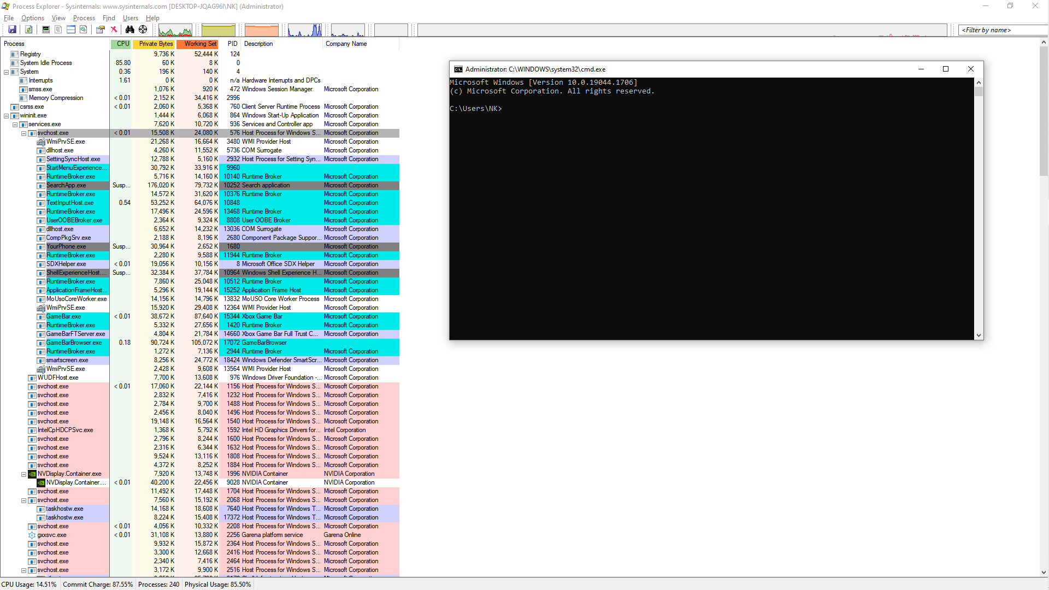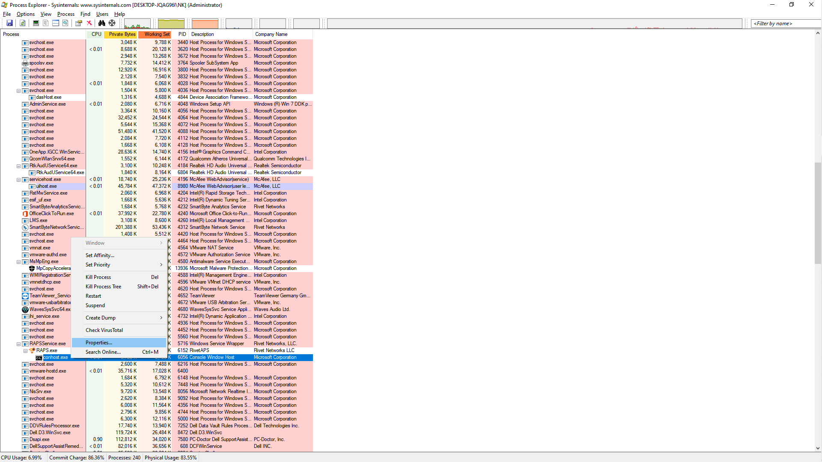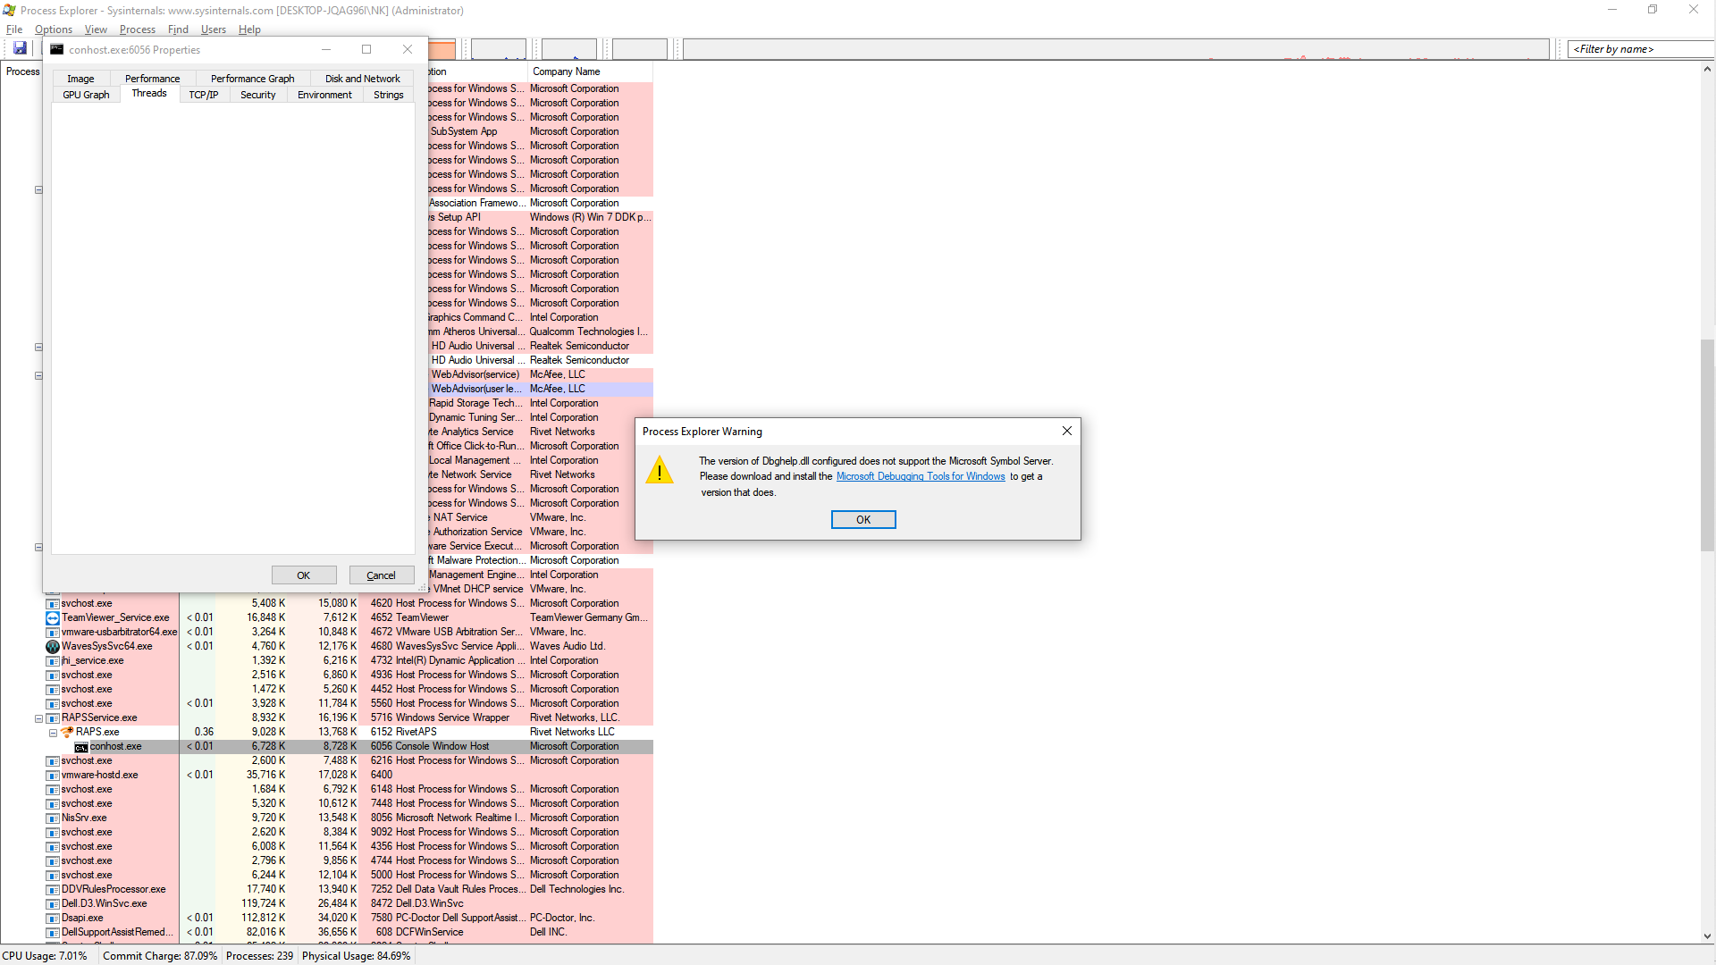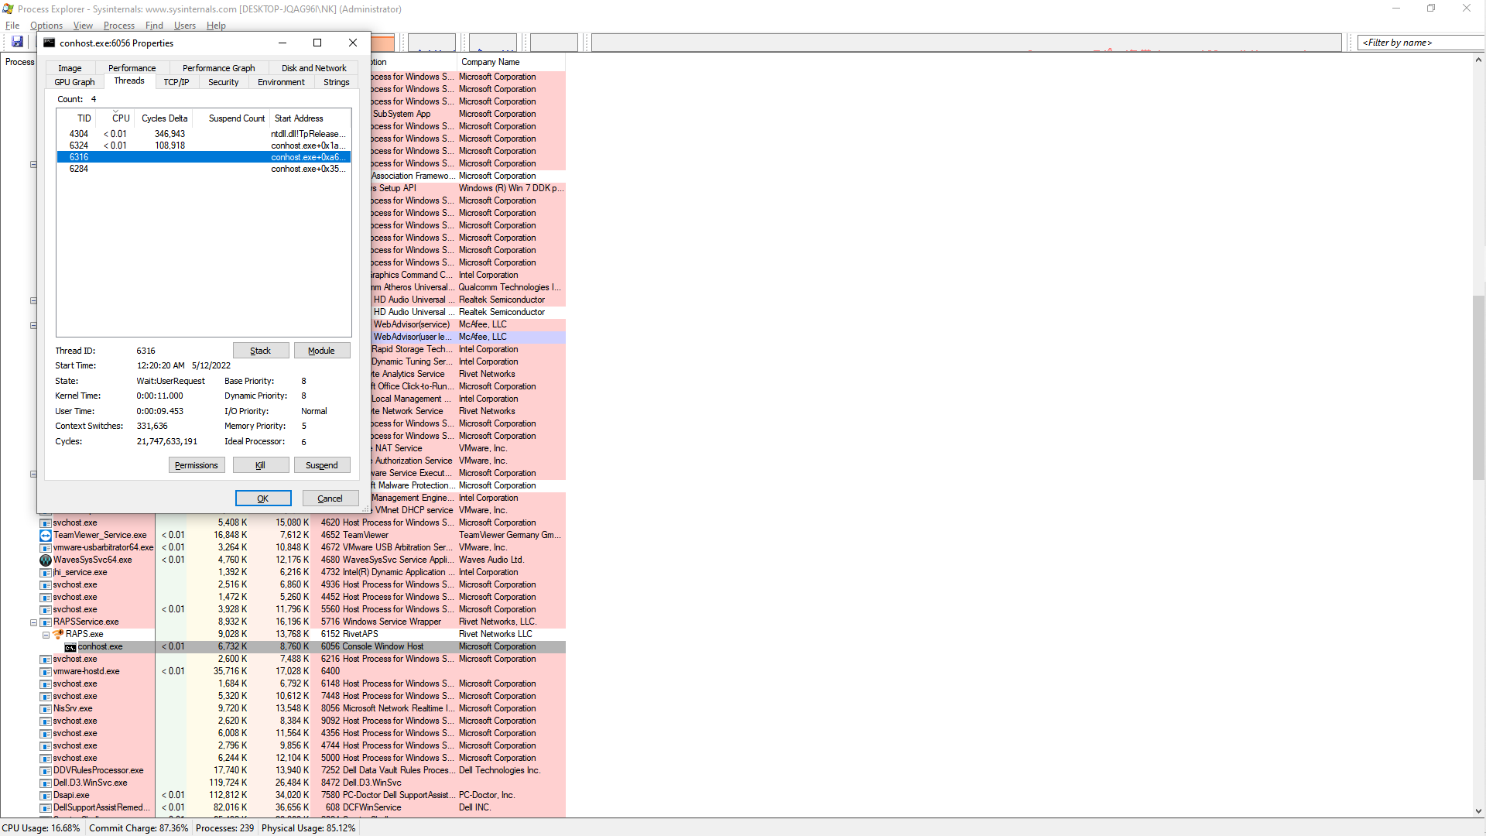

c. Examine the details of the thread.

Question: What type of information is available in the Properties window?

Answer: Information available includes environment variable, security information, performance information, and printable strings.

d. Click OK to continue.

Step 2: Explore handles

a. In the Process Explorer, click View > select Lower Pane View > Handles to view the handles associated with the conhost.exe process.

Examine the handles. What are the handles pointing to?

Answer:

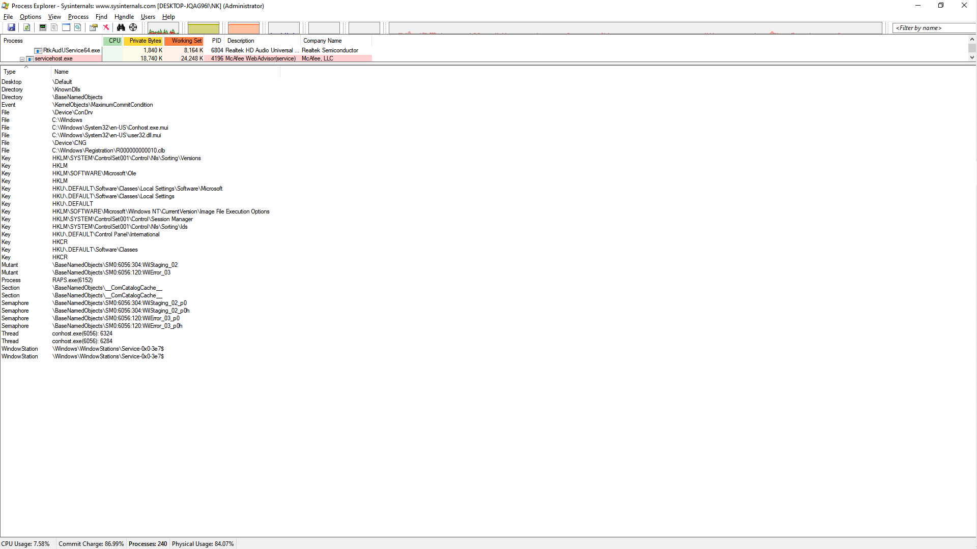

The handles are pointing to files, registry keys, and threads.

b. Close the Process Explorer when finished.